# Specifications

1. Create a new project in Visual Studio.
2. Copy the Driver class as given into the project; **you are not allowed to make modifications to this file.**
3. Create a class called *Item* as specified in the UML (see below)
   1. *Item* should have a single constructor that sets all its fields
   2. The *ToString* method should create a string that, when printed, looks similar to the following:  
      Item name: *Name*Description: *Description*Weight: *Weight* pounds  
      Value: *Value* gold pieces
   3. The *ToString* method should return a string, not print the information to the screen.
4. Create a subclass of *Item* called *Clue* as specified in the UML
   1. *Clue* must have a constructor that calls the superclass constructor
5. Create a subclass of *Item* called *Consumable* as specified in the UML
   1. *Consumable* must have a constructor that calls the superclass constructor
6. Create an enum called *DamageType* as specified in the UML
7. Create a subclass of *Clue* called *Weapon*
   1. *Weapon* must have a constructor that calls the superclass constructor
8. Create a class called *Backpack* as specified in the UML
   1. The *Add* method must add an *Item* to *Contents*
   2. The *ListWeapons* method must create a string listing each *Weapon* in *Contents* separated by a dotted line
   3. The *ListClues* method must create a string listing each *Clue* in *Contents* separated by a dotted line
   4. The *ListConsumables* method must create a string listing each *Consumable* in *Contents* separated by a dotted line
   5. The list methods should return a string, not print the items to the screen
9. Run the driver. Your output should closely resemble the sample output (see below).

# UML

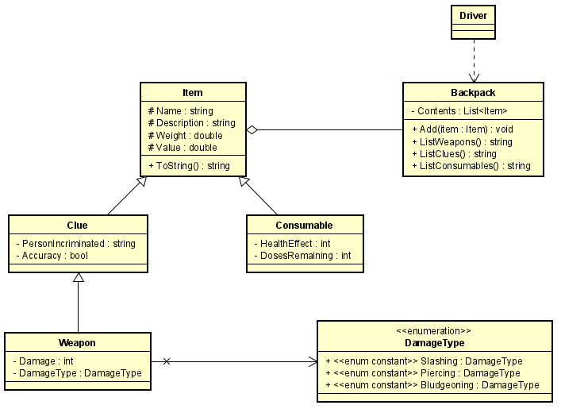

Note that some common methods, e.g., constructors, have been omitted from the UML, but are still needed in the implementation.

# Submission

Your submission should be a single **.zip** file with a name in the format of ***1260-LastFirst-Lab6*** containing your entire VS project. Submit the **one** **zipped** **file** to the **Lab 6 Dropbox** on D2L.

# Sample Output

